

**Name:** Hamza naveed

**Intern ID:** TN/IN02/PY/010

**Email ID :** hamza.live.016@gmail.com

**Task week:** 01

**Internship Domain:** Python Development

**Instructor Name:** Mr. Hassan Ali

# Tasks – Libraries and pip

## Task 01

**Collect user profile & print typed summary.**

### Step-by-Step Instructions

### Code & Output Snippet

### 

### Learning and Challenges

* Learned how to take input and printing values
* Handling number input

## Task 02

Swap two variables without temp var

### Code Output Snippet

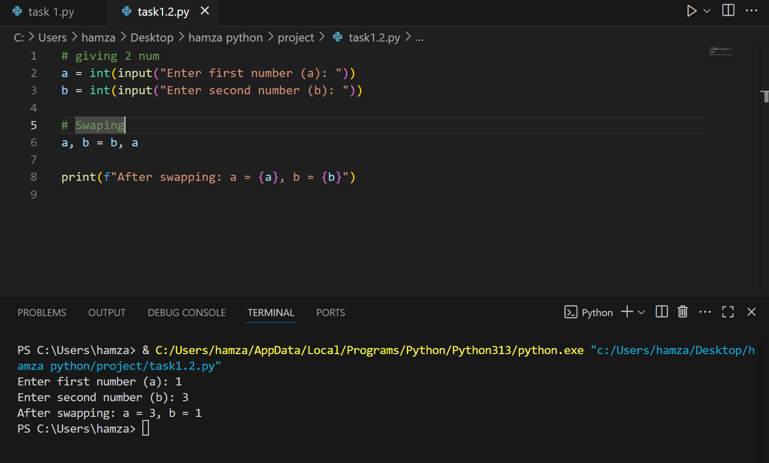

### Learning and Challenges

* Learned how to use python multiple assignments (a,b=b,a)
* Rimbering the syntex

## Task 03

**Read three numbers; output avg.**

### Code Output Snippet

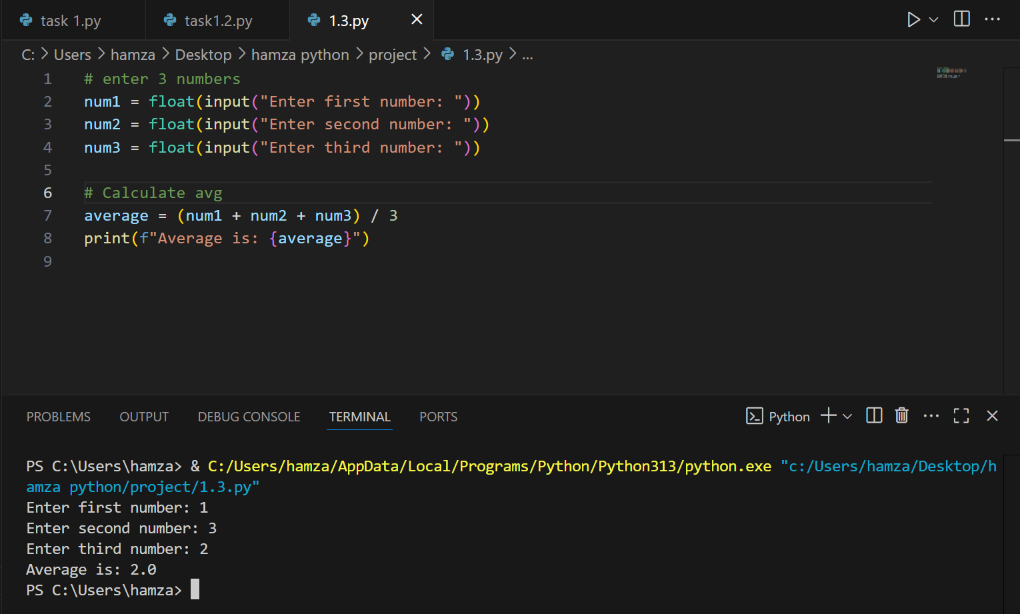

### Learning and Challenges

* Learned how to take multipl inputs and use floar()
* .issues in understanding float and int

## Task 04

**Convert minutes to hours + minutes.**

### Code Output Snippet

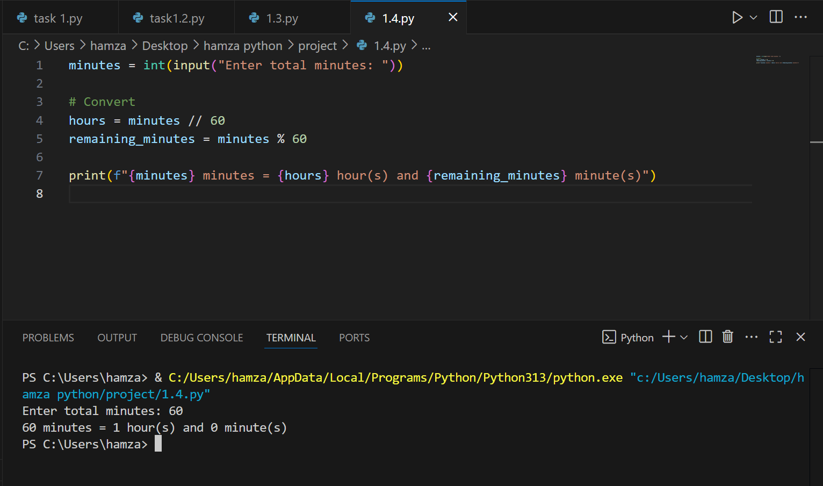

### Learning and Challenges

* Learned hoe to use integer divion and modulo
* Cunfude between / and %

## Task 05

**6. Simple interest calc**

### Code Output Snippet

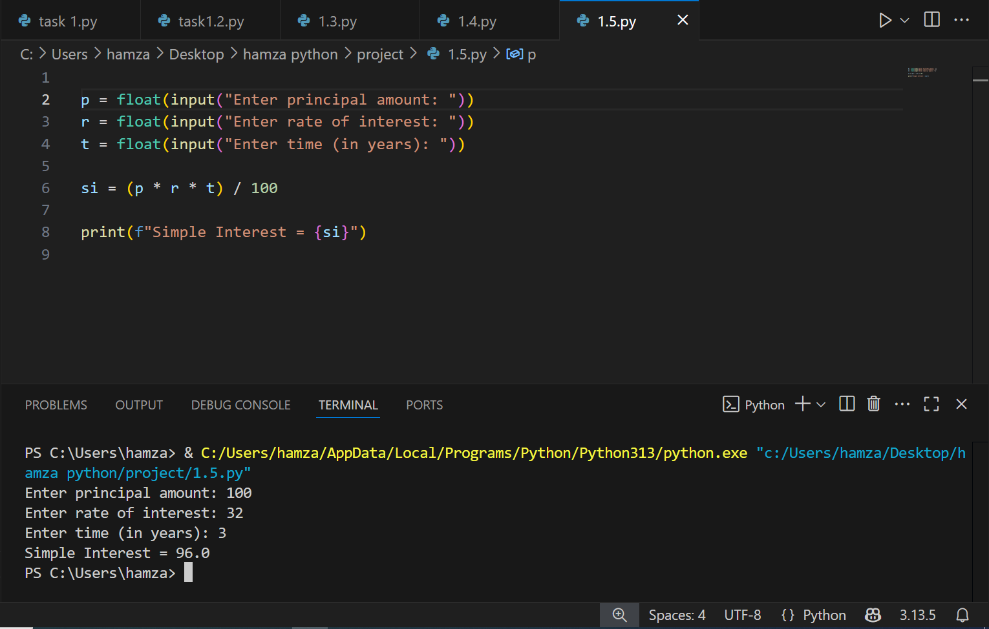

### Learning and Challenges

Learned how to use formulas in python

Remembering correct formula

## Task 06

### Username builder from full name.

### Code Output Snippet

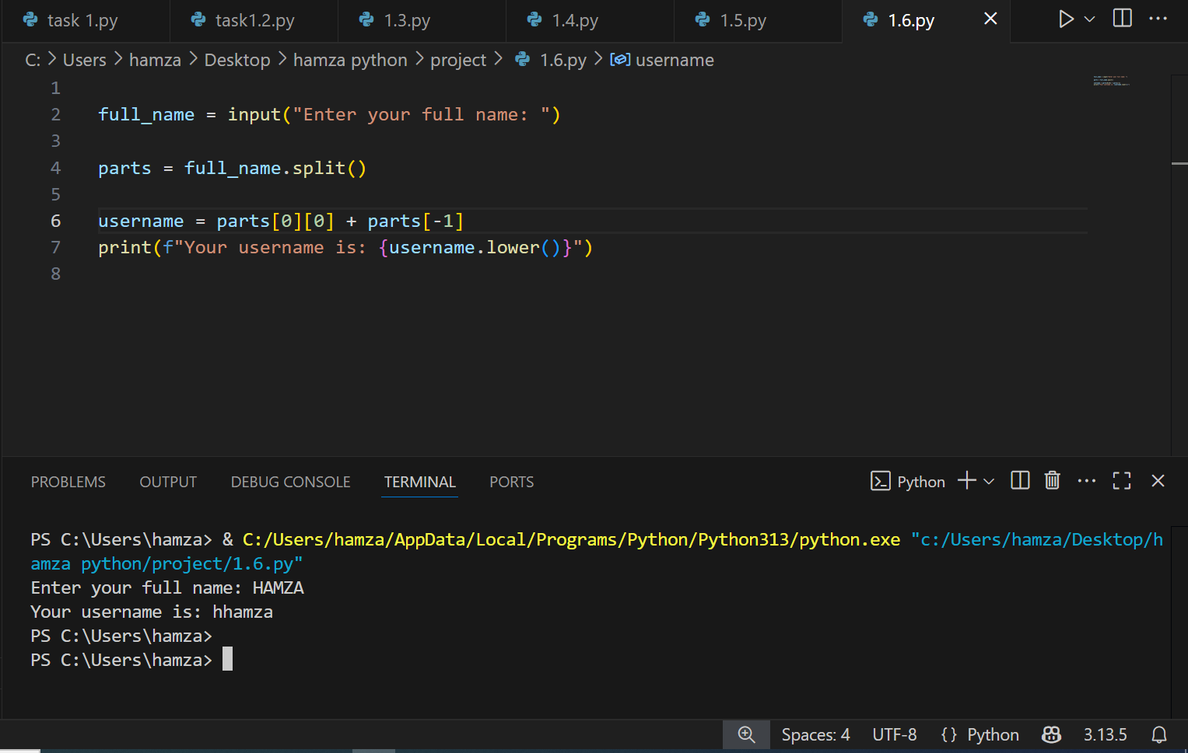

### Learning and Challenges

Learned how to use String methods (split(), lower()).

Not understanding Trimming extra spaces.

## Task 06

### Grade calculator.

**Learning and Challenges**

**Learned how to use condition in python**

**Who to define grades**

Task 07

### Multiplication table.

### Code Output Snippet

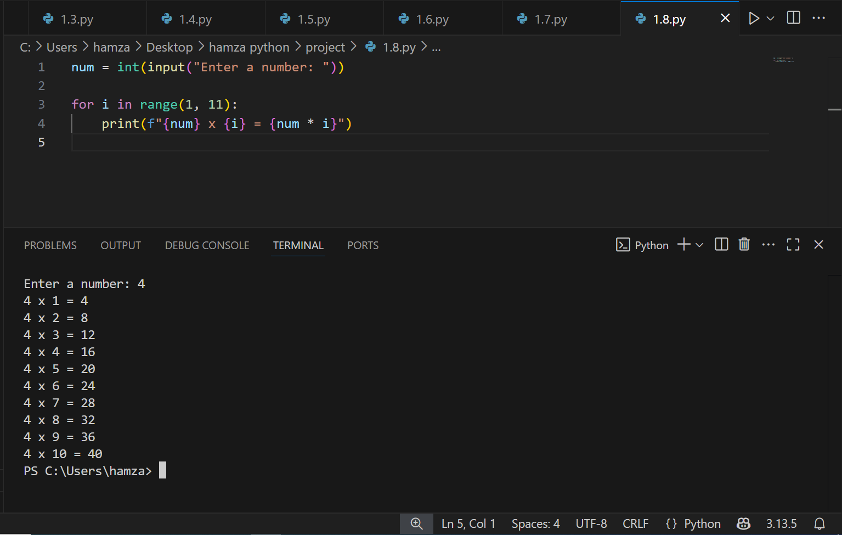

### Learning and Challenges

Learned how to use loops ipython

## Task 08

### Sum numbers divisible by 3

### Code Output Snippet

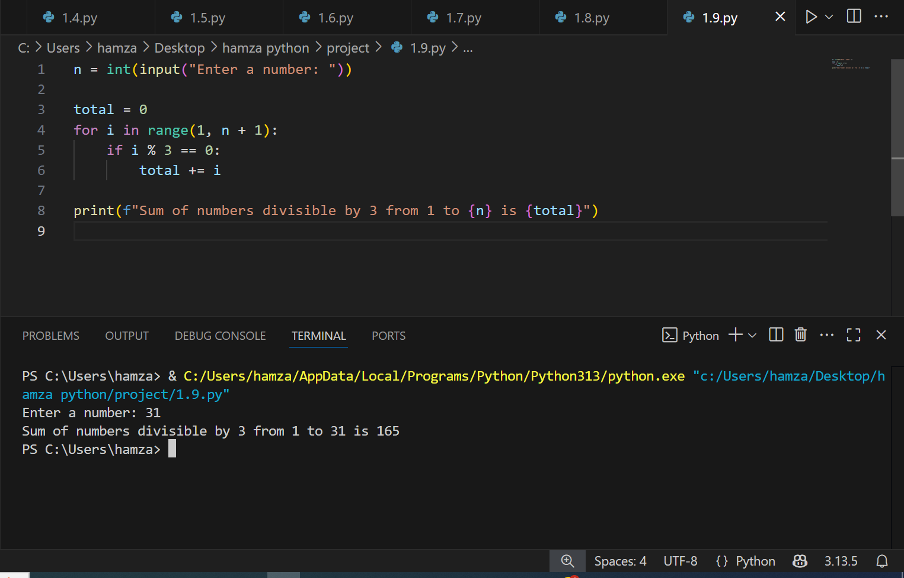

### Learning and Challenges

Learned hoe to use loping and coditionaal statements\

Off by one errorsoccured